**DAILY ONLINE ACTIVITIES SUMMARY**

|  |  |  |  |  |  |  |  |  |
| --- | --- | --- | --- | --- | --- | --- | --- | --- |
| **Date:** | **1/6/2020** | | | | | **Name:** | **Banish M G** | |
| **Sem & Sec** | **8th Sem** | | | | | **USN:** | **4AL16CS020** | |
| **Online Test Summary** | | | | | | | | |
| **Subject** | | **SMS** | | | | | | |
| **Max. Marks** | | **60** | | **Score** | | | **60** | |
| **Certification Course Summary** | | | | | | | | |
| **Course** | **Udemy: Python for Data science and Machine Learning** | | | | | | | |
| **Certificate Provider** | | | **Udemy** | | **Duration** | | | **23 hrs** |
| **Coding Challenges** | | | | | | | | |
| **Problem Statement:**  1.   Given an array of positive integers. Write a C Program to find the leaders in the array. | | | | | | | | |
| **Status:COMPLETED** | | | | | | | | |
| **Uploaded the report in Github** | | | | | **yes** | | | |
| **If yes Repository name** | | | | | B**anish_MG** | | | |
| **Uploaded the report in slack** | | | | | **yes** | | | |

Online Test Details: (Attach the snapshot and briefly write the report for the same)

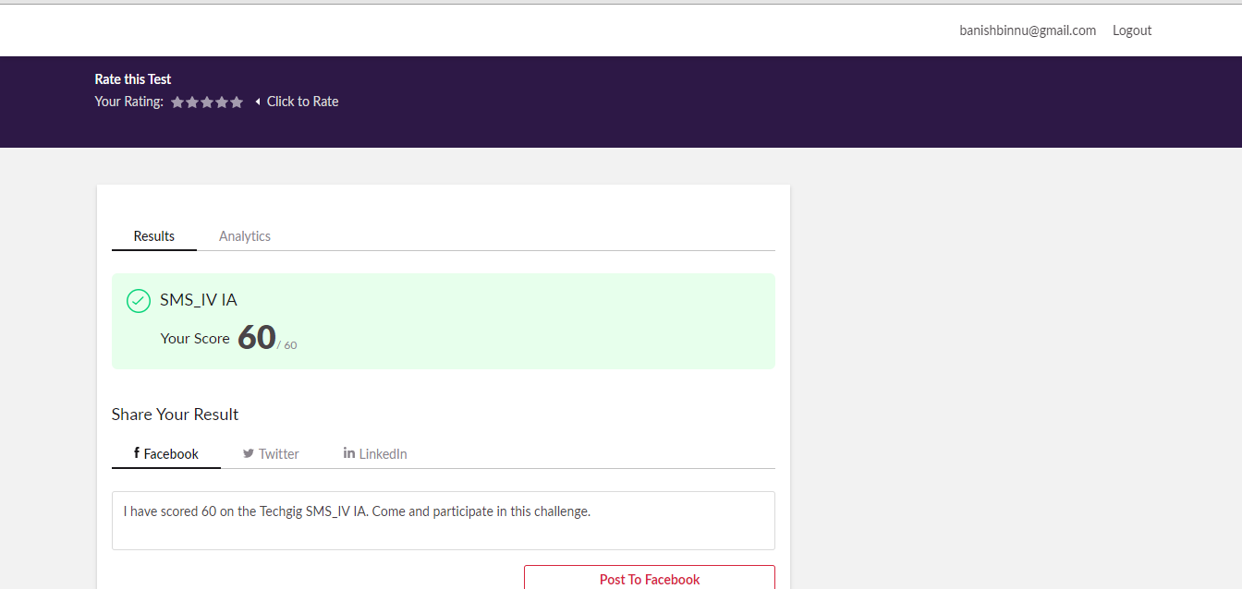

Certification Course Details: (Attach the snapshot and briefly write the report for the same)

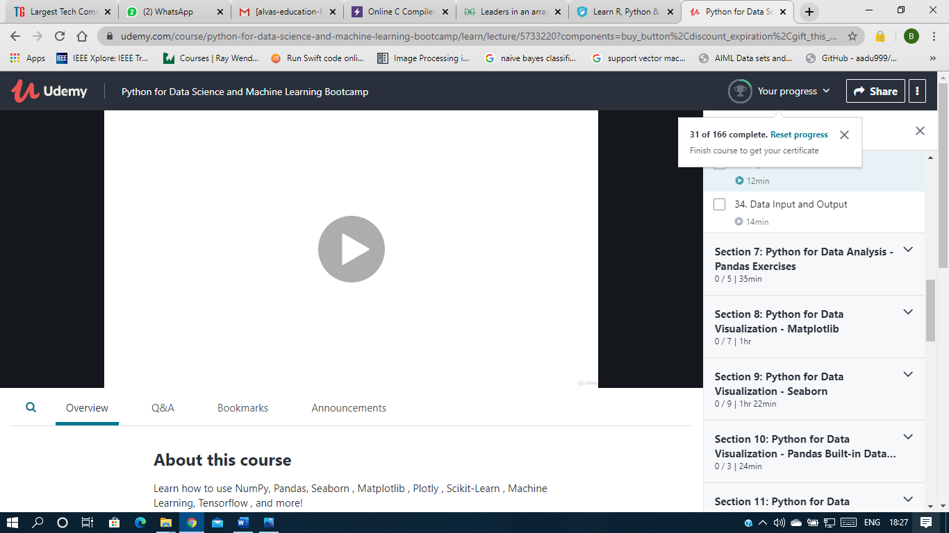

Coding Challenges Details: (Attach the snapshot and briefly write the report for the same)

Given an array of positive integers. Write a C Program to find the leaders in the array.

void printLeaders(int arr[], int size)

{

for (int i = 0; i < size; i++)

{

int j;

for (j = i+1; j < size; j++)

{

if (arr[i] <= arr[j])

break;

}

if (j == size) // the loop didn't break

printf(" %d ", arr[i] ) ;

}

}

int main()

{

int arr[100],i=0,n=0;

printf("enter the number of elements");

scanf("%d",&n);

printf("enter the array");

for(i=0;i<n;i++)

{

scanf("%d",&arr[i]);

}

printLeaders(arr, n);

return 0;

}